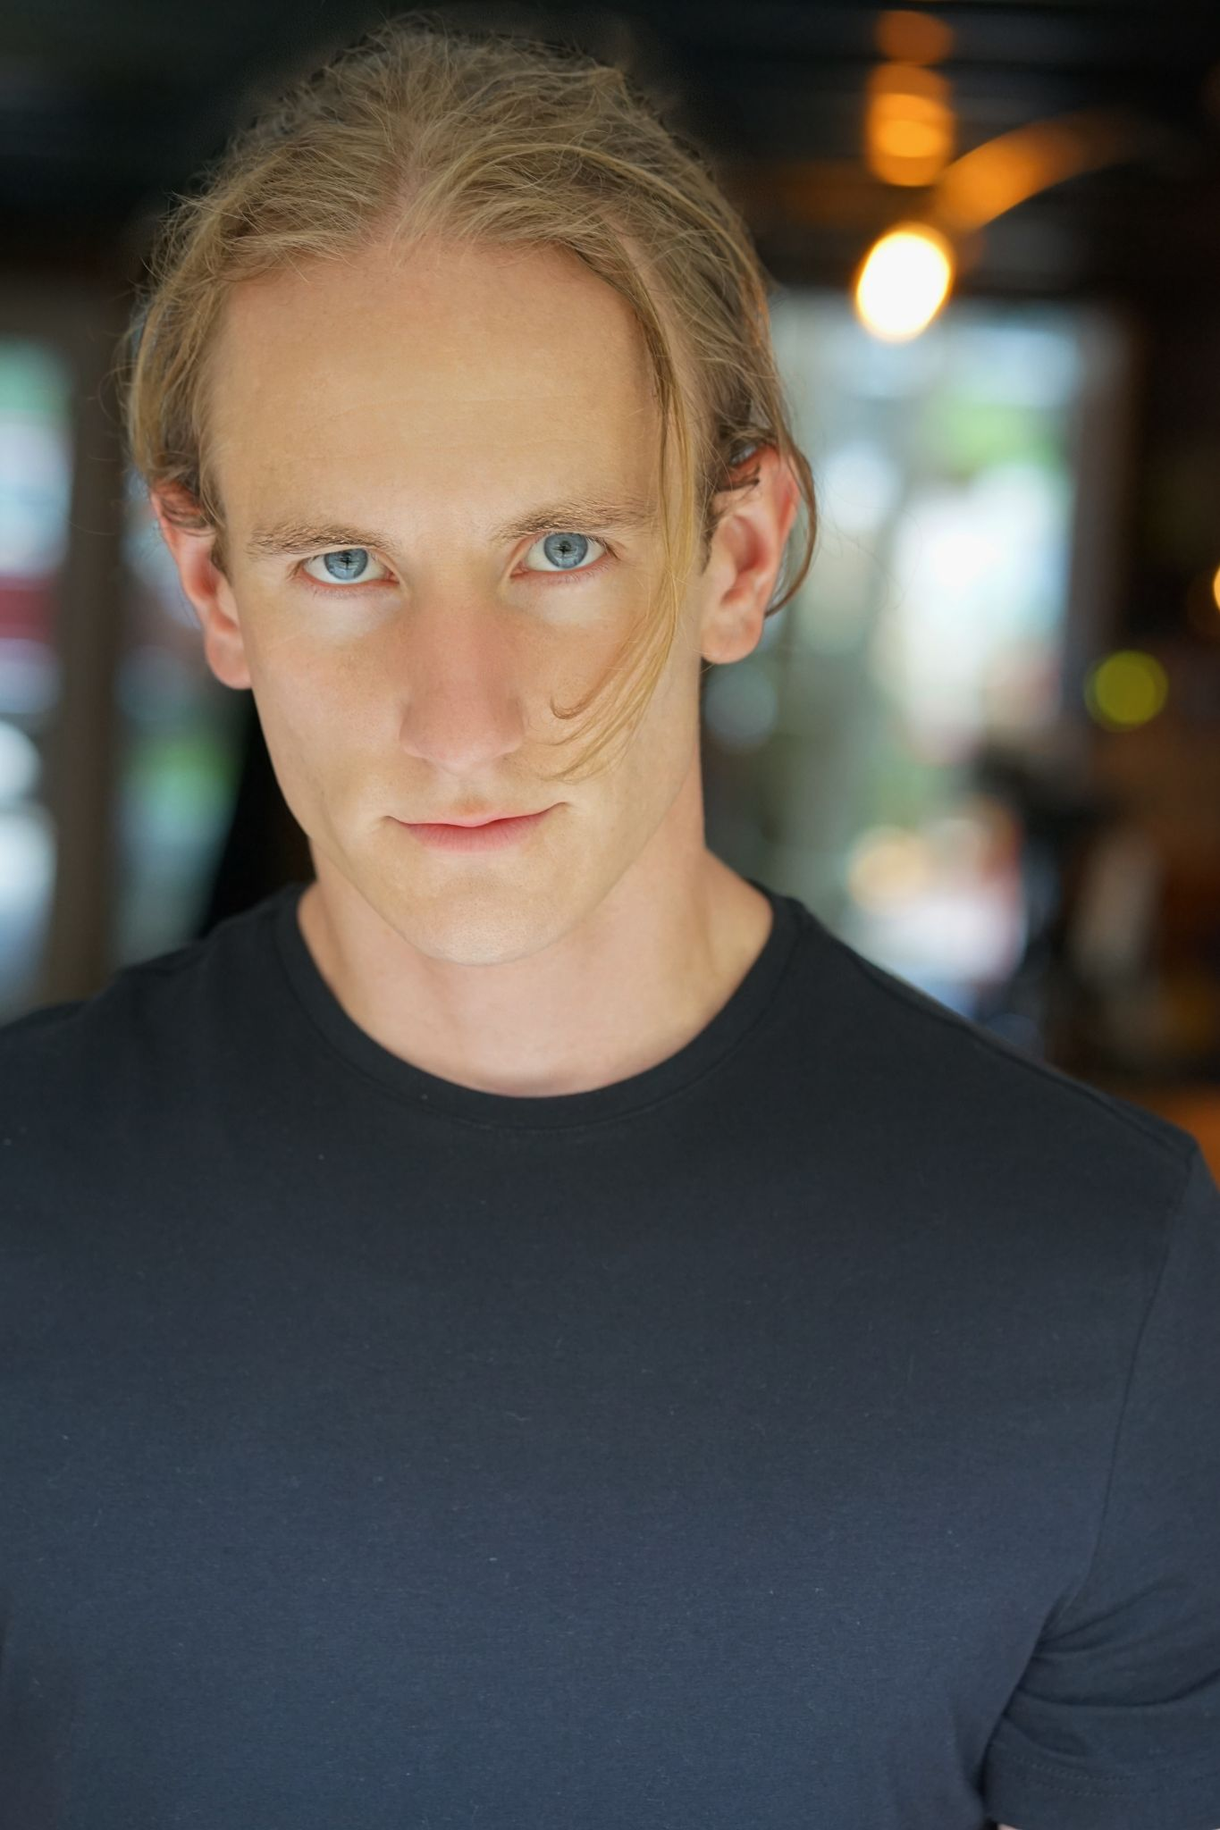 | Sean Ohlman
 | Hair: Blonde Weight: 155lbs.  Height: 5.10” Eyes: Blue |  | seandohlman@gmail.com  630-408-9900
Film & TV
“Jag ar Fri  “The South River”  “Remy”  “The Woman in The Photo”  “Fam Bam”  “Snapped Ep. Goylar  “Killer Couples Ep. Skinner/Kurtz  “O’Leary”  “The Hostess City”  “Boneyards”  “Carry On”  “Chicago PD Ep.9009”  Commercials |  | Ezra (Lead)  Three (Lead)  Remy (Lead)  Tony (Supporting)  Thomas Chello (Supporting)  Det. Jim Doty (Supporting)  James Preston (Supporting)  Kerrigan(Lead)  Torvin(Lead)  River(Lead)  Peter(Supporting)  Martin(Co-Star) | Producer: Lost Tourist Productions  Director: Jaidon Lalor  Director: Antonina Roman  Director: Xin Zhang  Director: Tom Bussineau  Oxygen Network  Oxygen Network  Producer:Lost Tourist Productions  Producer:Lost Tourist Productions  Producer:Lost Tourist Productions  Director:Anthony Paderewski  Producer:Dick Wolf
“Day in the Life” Great Dane Trailers  “Locker Room” Game Day  “SEC” Pizza Hut  Voice Overs & Misc. |  | Ted (Lead)  No.33  No.33 | Director: Anthony Paderewski  ESPN  ESPN
“COVID-19 Sgt. Maggio Story”  “What’s the Vibe?” Music video |  | Narrator(VO)  Boyfriend(Lead) | Winn Army Community Hospital  Goldmyne Entertainment
Training
“Acting 101” |  |  | College of DuPage
“On Camera Scene Study” |  |  | William Mark McCullough
“On Camera Audition” |  |  | William Mark McCullough
“Mixed Method” |  |  | Anthony Paderewski
“Meisner Technique Part 1” |  |  | Anthony Paderewski
“Working Actor Workshop”  “Spolin Acting/Benefit Workshop”  “On Camera Audition Workshop”  “Meisner Technique Part 2”  “On Tape Power Audition”  “Advanced Spolin Improv Workshop”  “Creating a Character Workshop”  “Improv for Audition Workshop” |  |  | Deja Dee  Jeanmarie Collins  Anthony Paderewski  Anthony Paderewski  Anthony Paderewski  Jeanmarie Collins  Anthony Paderewski  Chad Darnell
“Think before you Act” Anthony Paderewski
Skills
Southern, British, Australian, Irish, Scottish, Slavic, German, French, Spanish, Wisconsin, Minnesota, Canadian, Scandinavian, Boston & English Dialects, Weight Lifting, 10 years of Martial Arts, 10 years of Landscaping, Sports (Football, Baseball, Lacrosse, Basketball, Hockey), Drive Manual, Snowboarding, Surfing, Wakeboarding, Skiing, Waterskiing, Improvisation, 13 Years of Singing Experience, Play Guitar & Bass, Shooting Handguns, 13 years on-stage performing in bands.

